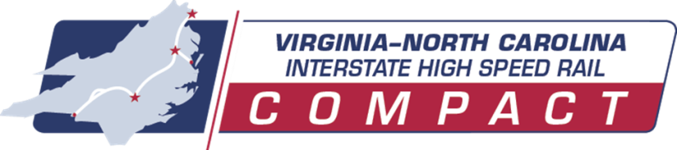
Agenda
Compact Meeting
December 11, 2023, 3:00 PM

Location: Virtual (Microsoft Teams)
Compact Members:
North Carolina Virginia
Senator Tom McInnis Senator Scott Surovell
Senator Michael Lazzara Delegate Carrie Coyner
Representative Matthew Winslow Delegate David Reid
Representative Ben Moss Delegate Jeion Ward
Board of Transportation Sec. Michael Fox

- Welcome and Introductions
NC Senator Tom McInnis, VA-NC IHSR Compact Co-Chair
VA Senator Scott Surovell, VA-NC IHSR Compact Co-Chair

- Compact Goals and VA-NC Collaborative Efforts
Jennifer DeBruhl, DRPT Director and VPRA Board Chair
Julie White, NCDOT Deputy Secretary for Multimodal Transportation

- Virginia Update
Virginia 2022 Statewide Rail Plan Update – Emily Stock, DRPT Chief of Rail Transportation
Transforming Rail in Virginia and Long Bridge Project Update – DJ Stadtler, VPRA Executive Director

- North Carolina Update
Jason Orthner, NCDOT Rail Division Director

- Future of the Compact and Additional Discussion

- Public Comment

- Adjourn

